FL-KubeOps — Project Schedule
Spring 2026 (April) through Fall 2026 (November)
Advisor: Mr. Zulkifl Hasan | Team: Faisal Khalid · Shah Wali · Wajeeh ur Rehman · M. Hammad

Task / Milestone | April 2026 |  | May 2026 |  | June 2026 |  | July 2026 (Exams+Break) |  | August 2026 |  | September 2026 |  | October 2026 |  | November 2026
 | 1–13 | 14–30 | 1–15 | 16–31 | 1–15 | 16–30 | 1–18 | 19–31 | 1–15 | 16–31 | 1–15 | 16–30 | 1–15 | 16–31 | 1–15 | 16–30
Proposal Submission & Idea Defense  All | ▲
Phase 1 (RS) — Requirements Spec.  All |  | ▲
K3s Cluster Setup & Verification
Wajeeh
System Architecture Design
Faisal
kopf Operator — Core Development
Faisal
PySyft FL Client Implementation
Shah Wali
Phase 2 (SDS) — Software Design Spec.  All |  |  |  |  |  | ▲
[ SEMESTER EXAMS & BREAK ]
Kubeflow Pipelines Integration
Wajeeh
Secure Aggregation Module (PySyft SMPC)
Shah Wali
End-to-End Testing & Benchmarking
Hammad
Phase 3 (DTS) — Design & Test Spec.  All |  |  |  |  |  |  |  |  |  |  | ▲
Documentation, Polish & Peer Review
Hammad
Phase 4 (Final) — Complete System  All |  |  |  |  |  |  |  |  |  |  |  |  |  |  | ▲
Bi-weekly Advisor Meetings
All
Legend: | Development |  |  | ▲ Milestone |  |  | Exams / Break |  |  | Advisor Meetings

Important Dates: Semester 1 Midterm: April 20–25, 2026 | Final Exams: June 29 – July 8, 2026 | Semester Break: July 9–18, 2026 | Semester 2 Start: July 20, 2026 | ▲ = Phase submission milestone

Work Breakdown Structure (WBS)
FL-KubeOps: Secure Orchestration of Federated Learning Clients

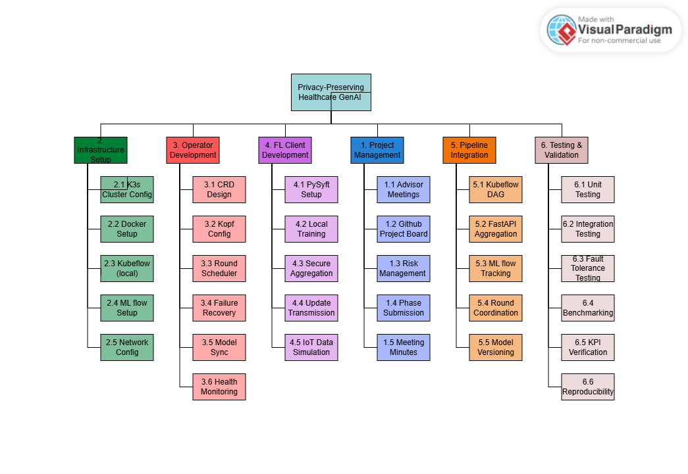WBS Notes: The WBS is organized into 6 top-level domains reflecting the system's major engineering areas. Each domain maps to one or more GitHub repositories and team member responsibilities. Domain 3 (Operator) and Domain 4 (FL Clients) are the core technical deliverables. Domain 1 (Project Management) runs throughout both semesters. Total work packages: 33.

Domain Ownership:
No. | Domain | Primary Owner | GitHub Repo | Semester
1 | Project Management | All Members (Faisal leads) | docs | Sem 1 + Sem 2
2 | Infrastructure Setup | Wajeeh ur Rehman | operator, pipeline | Sem 1 (early)
3 | Operator Development | Faisal Khalid | operator | Sem 1 + Sem 2
4 | FL Client Development | Shah Wali | fl-clients | Sem 1 + Sem 2
5 | Pipeline Integration | Wajeeh ur Rehman | pipeline | Sem 1 (late) + Sem 2
6 | Testing & Validation | M. Hammad | all repos | Sem 2

Completeness Criteria
FL-KubeOps: Measurable success indicators for FYP evaluation
The project is considered fully complete when each of the following criteria is independently verifiable by the FYP evaluation committee. Each criterion maps directly to a system component and has an explicit, observable test condition. Weightages reflect engineering complexity and research significance.
S.No | Criteria | Measurable Outcome / Success Indicator | Weightage (%)
1 | Kubernetes Operator Implementation | kopf-based FLCluster CRD is created, updated, and deleted cleanly. Operator reconciliation loop runs without crashing on a live K3s cluster. FLCluster resource status reflects real-time round state. | 20%
2 | FL Training Round Execution | A complete federated training round (model broadcast → local training → update collection → aggregation → round counter increment) executes end-to-end across a minimum of 4 client nodes without manual intervention. | 20%
3 | Secure Aggregation (PySyft SMPC) | Individual client model updates are aggregated using Secure Multiparty Computation. No single client update is recoverable from the aggregated result. Verified by inspection of intermediate data at the aggregation server. | 15%
4 | Fault Tolerance & Recovery | System detects a simulated client pod failure mid-round, reschedules or proceeds with remaining quorum, and completes the training round. Recovery time is logged and is within 60 seconds of failure onset. | 15%
5 | Kubeflow Pipeline Integration | FL training lifecycle is defined as a reproducible Kubeflow DAG pipeline. Pipeline executes minimum 10 rounds. All round results, metrics, and model versions appear in MLflow experiment tracking dashboard. | 10%
6 | Benchmarking & KPI Verification | Federated model achieves ≥85% of centralized model accuracy on IoT anomaly detection benchmark. Communication overhead per round is measured and documented. All 4 KPIs from Section 8 are met and independently verifiable. | 10%
7 | Deployment Guide & Reproducibility | A third party can deploy the complete FL-KubeOps system on any K3s cluster by following the published GitHub guide without team assistance. Deployment guide is tested by at least one team member not involved in writing it. | 10%
 | TOTAL | All criteria independently verifiable by FYP evaluation committee | 100%

Evaluation Method: Each criterion will be demonstrated live during the Phase 4 (Final) evaluation session. The evaluator may request a re-run of any specific test case. All benchmark data will be available in the GitHub repository and MLflow experiment dashboard at the time of evaluation.

Comparison with Existing Solutions
FL-KubeOps positioned against the current FL infrastructure landscape
The table below compares FL-KubeOps against the four most relevant existing approaches: Flower (the dominant FL research framework), OpenFL (Intel's enterprise FL solution), stock Kubeflow (the MLOps platform FL-KubeOps extends), and a manual FL deployment approach representing the current industry baseline. The comparison criteria are drawn from Li et al. (2020)'s taxonomy of FL system challenges.
Feature | FL-KubeOps (This Project) | Flower (Beutel et al., 2020) | OpenFL (Intel, 2021) | Kubeflow (Vanilla / Stock) | Manual FL Deployment
Kubernetes-Native Operator (CRD) | ✔ Yes — FLCluster CRD managed by kopf controller | ✗ No — runs on K8s but not as an operator | ✗ No — no CRD abstraction | ~ Partial — TFJob/PyTorchJob only; no FL round concept | ✗ No — manual pod management required
FL Round Orchestration | ✔ Yes — automated fan-out, quorum wait, aggregation, advance | ✔ Yes — built-in strategy engine | ✔ Yes — plan-based workflow | ✗ No — no round concept | ✗ No — fully manual per round
Secure Aggregation (SMPC) | ✔ Yes — PySyft SMPC; server cannot recover individual updates | ~ Partial — SecAgg available in experimental branch | ✔ Yes — TLS + SMPC support | ✗ No — no FL privacy primitives | ✗ No — depends entirely on implementer
Automatic Failure Recovery | ✔ Yes — operator detects pod failure, reschedules within 60s | ✗ No — client dropout is caller's responsibility | ~ Partial — limited retry logic | ✗ No — standard K8s pod restart only | ✗ No — no recovery mechanism
MLflow Experiment Tracking | ✔ Yes — every round versioned; metrics in MLflow dashboard | ✗ No — no built-in experiment tracking | ✗ No — no MLflow integration | ✔ Yes — native MLflow + KFP integration | ✗ No
Declarative Configuration (YAML/CRD) | ✔ Yes — single FLCluster manifest deploys full FL cluster | ✗ No — Python API only | ✗ No — JSON plan files | ✔ Yes — pipeline YAML definitions | ✗ No — imperative scripts only
Edge / Local Hardware Support | ✔ Yes — runs on K3s on commodity laptops | ✔ Yes — any Python environment | ~ Partial — enterprise-focused; cloud preferred | ~ Partial — requires full K8s; resource heavy | ✔ Yes — hardware agnostic
Kubeflow Pipeline Integration | ✔ Yes — FL round DAG in Kubeflow Pipelines | ✗ No | ✗ No | ✔ Yes — native | ✗ No
Python-Native Implementation | ✔ Yes — 100% Python stack — kopf, PySyft, KFP SDK | ✔ Yes — Python | ~ Partial — Python client; some Go infrastructure | ~ Partial — Python SDK; Go core | ✔ Yes — typically Python
Open Source & Reproducible | ✔ Yes — MIT license; full GitHub reproducibility guide | ✔ Yes — Apache 2.0 | ✔ Yes — Apache 2.0 | ✔ Yes — Apache 2.0 | ✗ No — typically internal scripts
Designed for FL as a First-Class Workload | ✔ Yes — core design principle; FL = native K8s resource | ~ Partial — FL-first algorithm design; infra is secondary | ~ Partial — enterprise FL-first; K8s is deployment environment | ✗ No — general ML platform; FL is an afterthought | ✗ No — no design principle; ad-hoc

Key differentiator: FL-KubeOps is the only solution that treats Federated Learning as a first-class Kubernetes workload — expressing the complete FL cluster as a declarative custom resource (FLCluster CRD) and managing it through a native Kubernetes operator. No existing open-source tool occupies this architectural position.
References: Flower — Beutel et al., arXiv:2007.14390, 2020. OpenFL — Reina et al., arXiv:2105.06413, 2021. Kubeflow — kubeflow.org, v1.8, 2024. Li et al. taxonomy — IEEE Signal Process. Mag., vol. 37, no. 3, 2020.

